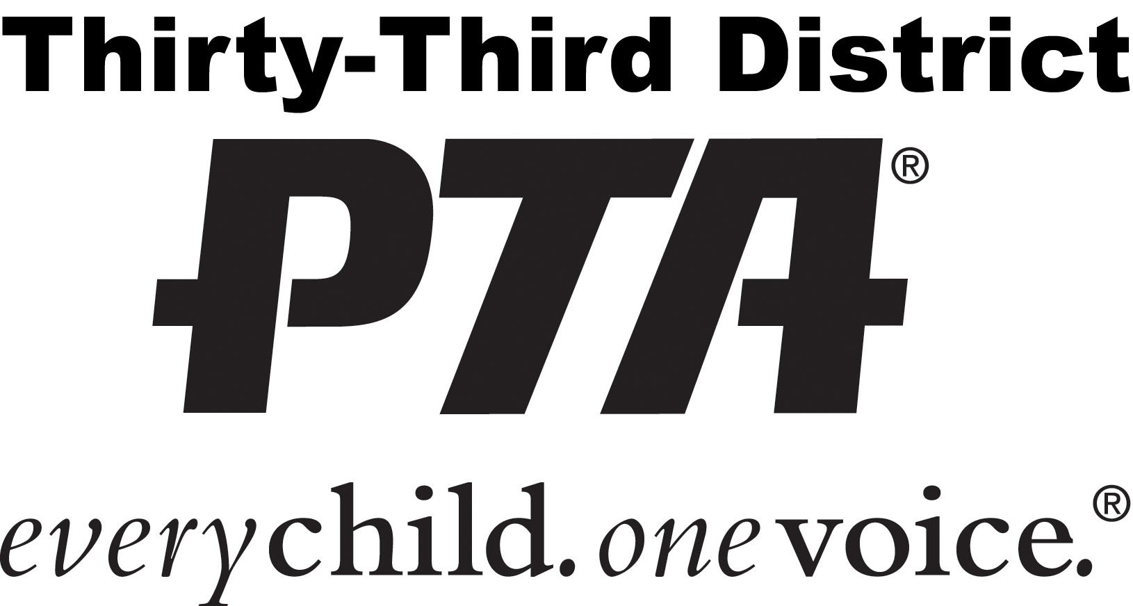
Thirty-Third District PTA
Annual Meeting Minutes
The Grand, Long Beach, CA
February 6, 2020
Present: See registration sign in sheets for attendance attached to master copy
Call to Order: The meeting was called to order at _______ a.m. at the Hawthorne Memorial Center. President Cindy Ellenberg presiding.
Appointment of Minutes Review Committee
Pledge of Allegiance: The pledge of allegiance was led by
Introductions:
Welcome—Mid Year Inspiration:
Credential Committee Review
Reading and Adoption of the Rules and Regulations
Adoption of Agenda: The agenda was adopted as printed corrected.
Approval of the Minutes:
Recommendations from the Board of Directors—Sumi Arnheim

President’s Report—Cindy Ellenberg
First Vice President—Julie France
Director of Leadership—Michelle VanLerberghe
Director of Membership—Brad Waller
Director of Communications—Nannette Nolan
Director of Education—Marcy Cottrell
Director of Programs—Raymur Flinn
Director of Community Concerns—Beth Meyerhoff
Director of Heath—Kathie Haley
Financial Reports
Financial Secretary— Jocelyn Sisneros
Jo Sisneros presented the Financial Secretary’s report:
Financial Secretary’s Report:
Total remits $
Membership through 2018
Membership through 2019
Difference
Report filed for audit
Treasurer— Elena Wraight
Treasurer’s Report
Balance on hand as of
Total deposits
Total disbursements
Ending balance

Bank of America CD
Balance on hand as of
Total deposits
Total disbursements
Ending balance

Report filed for audit

Government and Tax Filings—Lisa Uyematsu

Auditor—Flora Farzad
Director of Legislation—Anita Avrick
Parliamentarian—Linda Morgan
Historian—Patti DiLeva
Recording Secretary—Sumi Arnheim
Corresponding Secretary—Michael Morgan
Announcements

Meeting was adjourned at.

Sumiye Arnheim
Recording Secretary

__________ date adopted as printed __________ date adopted as corrected

